AI BOOTCAMP • DAY 12 LAB
Smart Parking + EV Energy Settlement
Web GUI parameter guide and settlement interpretation
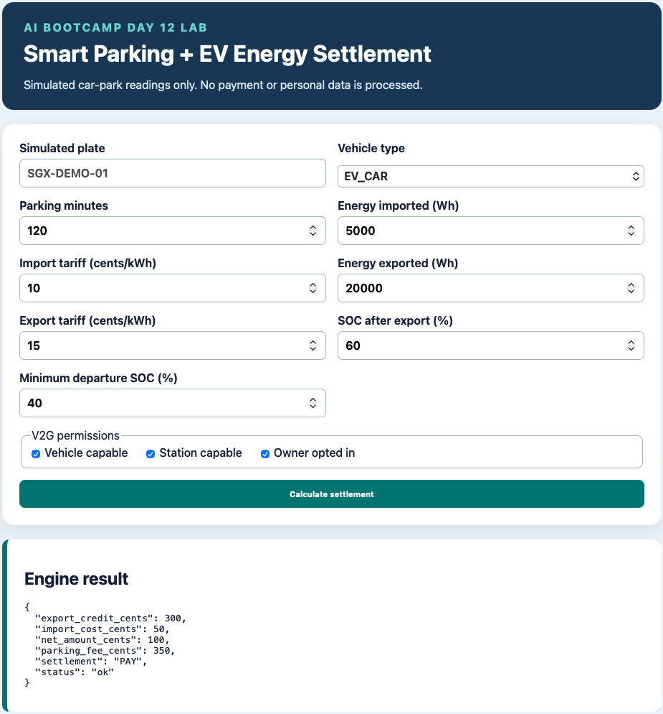
Figure 1. Web interface after calculating a simulated settlement.

1. Purpose and workflow
The GUI collects simulated parking, charging, tariff, permission, and battery readings. After Calculate settlement is selected, Flask sends the values to the compiled C++ engine and displays the engine’s JSON result. No real payment, vehicle identity, or personal data is processed.
Calculation principle
Net amount = parking fee + imported-energy cost − exported-energy credit. A positive result is PAY, zero is ZERO, and a negative result is CREDIT owed to the driver.

2. Vehicle and parking parameters
Simulated plate — A demonstration identifier such as SGX-DEMO-01. It provides interface context only; the current C++ calculation does not use the plate number.
Vehicle type — EV_CAR is an electric vehicle; ICE_CAR is an Internal Combustion Engine car; MOTORCYCLE is a motorcycle. Vehicle type changes the parking tariff and determines whether energy export can be valid.
Parking minutes — Total duration of the settlement record. Q1 intentionally accepts 0–1440 minutes, representing at most one 24-hour period. A production system would define how multi-day stays are split or aggregated.

3. Energy and tariff parameters
Energy imported (Wh) — Electricity transferred from the charging station into the EV battery. Wh means watt-hour; 5,000 Wh equals 5 kWh.
Import tariff (cents/kWh) — Price charged to the driver for imported electricity. For 5,000 Wh at 10 cents/kWh, the import cost is 5 kWh × 10 = 50 cents.
Energy exported (Wh) — Electricity transferred from the EV battery back to the charging station or local energy system through vehicle-to-grid operation. Export creates a driver credit.
Export tariff (cents/kWh) — Price paid to the driver for exported electricity. For 20,000 Wh at 15 cents/kWh, the export credit is 20 kWh × 15 = 300 cents.
Units and rounding
The engine calculates cents as round-half-up(Wh × cents/kWh ÷ 1,000). Integer cents are used to avoid unreliable floating-point comparisons for money.

4. Battery and V2G safety parameters
SOC after export (%) — SOC means State of Charge. This is the estimated battery percentage remaining after the proposed export.
Minimum departure SOC (%) — The lowest battery level the owner requires at departure. An export is rejected when the predicted SOC after export is below this threshold.
Vehicle capable — The EV supports bidirectional energy transfer. Some EVs can charge but cannot export energy.
Station capable — The charging station supports bidirectional transfer. Both vehicle and station must be capable.
Owner opted in — The owner has explicitly consented to energy export. Technical capability alone is not sufficient.
V2G export rule
Export requires EV_CAR, vehicle capability, station capability, owner opt-in, and SOC after export greater than or equal to minimum departure SOC. If any condition fails, the engine returns an error.

5. Reading the engine result
The result panel exposes structured fields rather than only a prose message:
status — ok for a valid calculation; error when an input or policy condition is invalid.
parking_fee_cents — Parking charge after the grace period, started-hour rules, and daily cap.
import_cost_cents — Amount charged for electricity imported into the EV.
export_credit_cents — Amount credited for electricity exported from the EV.
net_amount_cents — Final amount after adding fees and import cost, then subtracting export credit.
settlement — PAY, ZERO, or CREDIT according to the sign of the net amount.

6. Worked example from Figure 1
Item | Calculation / result
Parking | 120 minutes → 350 cents
Imported energy | 5,000 Wh = 5 kWh; 5 × 10 cents = 50 cents
Exported energy | 20,000 Wh = 20 kWh; 20 × 15 cents = 300 cents credit
Net amount | 350 + 50 − 300 = 100 cents
Settlement | PAY — the driver owes 100 cents

7. Useful demonstrations
- PAY: use a normal parking fee with little or no export credit.
- ZERO: choose an export credit exactly equal to parking plus import cost.
- CREDIT: choose a valid export credit greater than parking plus import cost.
- Safe rejection: clear one V2G permission or set SOC after export below minimum departure SOC.

8. Interface behaviour
- After calculation, the submitted values remain in the form so the displayed result can be checked against the exact inputs.
- The Flask host and port are read from config/app_config.json. If port 5000 is occupied, change the port, restart Flask, and open the printed address.
- The displayed plate remains a simulation label and is not included in settlement arithmetic.
Scope reminder
This GUI is a teaching simulator. Real deployment would also require authenticated identities, trusted meters, tariff versions, transaction records, consent evidence, human approval for consequential operations, and secure payment integration.

